The method of add drive for touch TFT (Raspberry Pi)
1.Connect the touch screen LCD with the raspberry pi board well.

- If you have your own raspberry pi system, you can add drive directly, if not, please download the latest image from the official raspberry pi website.
Here is the link: https://www.raspberrypi.org/downloads/raspbian/
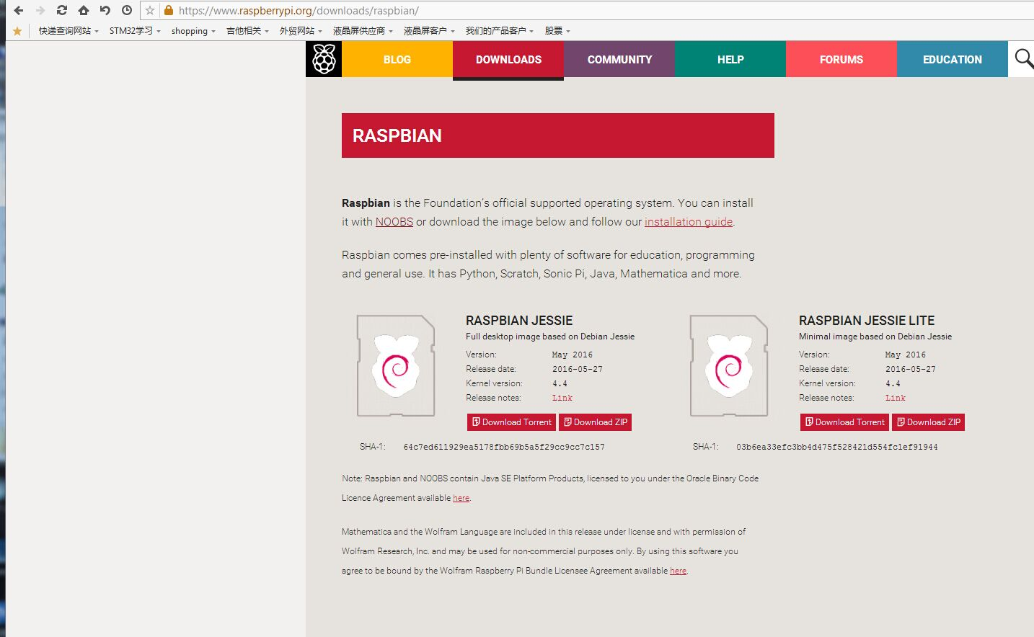
3.After download, burn it to SD card by windiskImage software.

4.Copy the drive into the SD card directly. (Connect the burned SD card with the computer by the card reader, and then put the drivers in)
As graph:
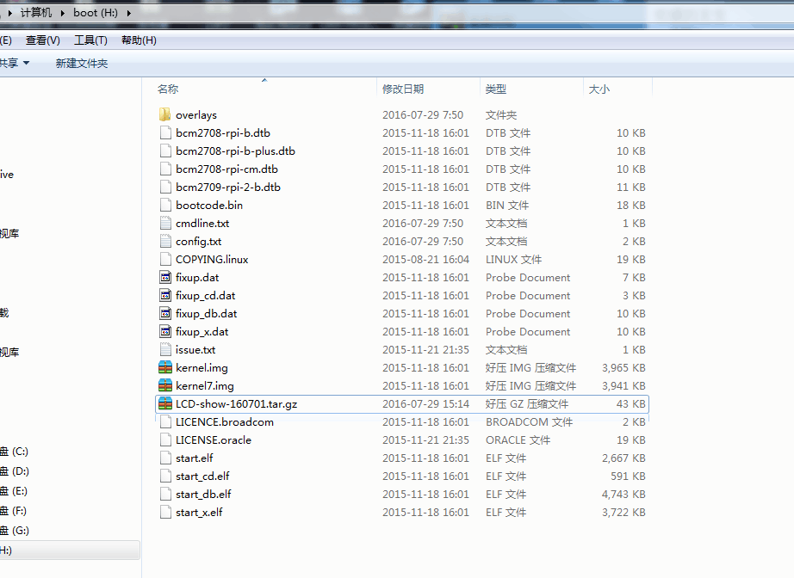
5.Insert the SD card into the raspberry pie, then power on and wait for 1 minutes, the screen will boot.

6.Remote login with SSH on the backstage of raspberry pie; there is a “putty.exe” software, before using it, please insert the cable into the board of raspberry pie, and you will find the IP address of the network by he router or other ways.
The following picture is the backstage of raspberry pie by the “putty.exe” software.

As graph:
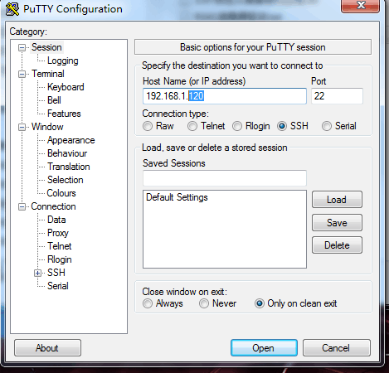
Input the IP which you find before in the “IP address” position, then click “Open”, and get into backstage.

7.As graph:
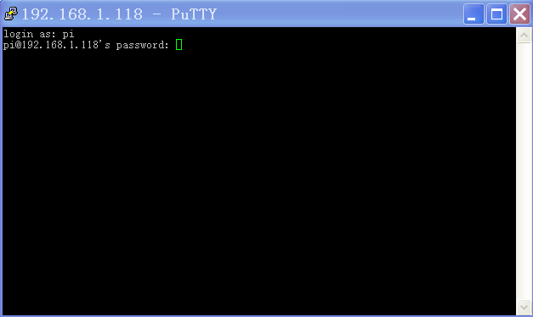
Login account is “pi”
Login password is “Raspberry” (it must be lowercase, due to the system is encrypted, the letters will not display it is upper or lowercase when typing.

Input “ Enter”, as graph:
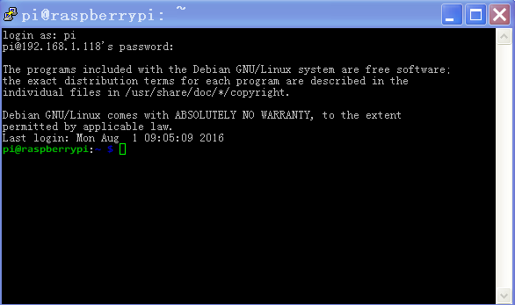

Indicate you entered in the backstage already.

8. Next is the process of entering the system disk and decompression drive, install the drive.

- If you want to install the 2.8inch screen, please copy the following contents directly:

cd /boot
sudo tar zxvf LCD-show-160701.tar.gz
cd LCD-show/
sudo ./LCD28-show

Paste here is okay. (Note: There is no ctrl+V function in “putty”, use the right-click is fine )

As graph:
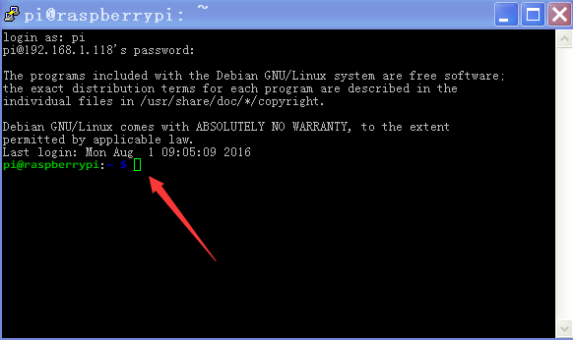

And then this appears,
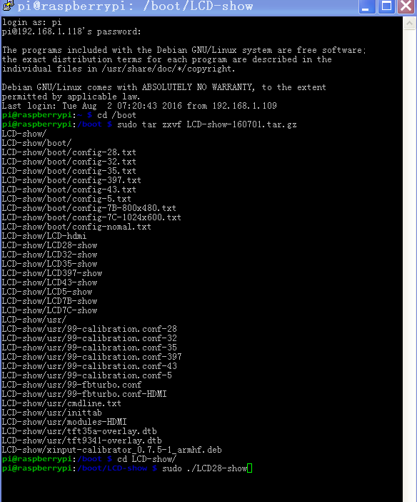

Add successful, then wait for automatic restart

All size drivers can be added in this way.

- If you want to install the 3.2 inch screen, copy the following contents directly:

cd /boot
sudo tar zxvf LCD-show-160701.tar.gz
cd LCD-show/
sudo ./LCD32-show

Paste is okay. (Note: There is no ctrl+V function in “putty”, use the right-click is fine)

3）If you want to install the 3.5 inch screen, copy the following contents directly:

cd /boot
sudo tar zxvf LCD-show-160701.tar.gz
cd LCD-show/
sudo ./LCD35-show

Paste can be. (Note: There is no ctrl+V function in “putty”, use the right-click is fine )

4）If you want to install the 4.3 inch screen, copy the following contents directly:

cd /boot
sudo tar zxvf LCD-show-160701.tar.gz
cd LCD-show/
sudo ./LCD43-show

Paste is okay. (Note: There is no ctrl+V function in “putty”, use the right-click is fine)

5）If you want to install the 5 inch screen, copy the following contents directly:

cd /boot
sudo tar zxvf LCD-show-160701.tar.gz
cd LCD-show/
sudo ./LCD5-show

Paste is okay. (Note: There is no ctrl+V function in “putty”, use the right-click is fine)

6）If you want to install the 7 inch screen（800*480）, copy the following contents directly:

cd /boot
sudo tar zxvf LCD-show-160701.tar.gz
cd LCD-show/
sudo ./LCD7B-show

Paste is okay. (Note: There is no ctrl+V function in “putty”, use the right-click is fine)

Then please waiting for auto restart,

When the screen shows, and you can touch it.

It means the divers are added successful.

If you want to switch back to the HDMI display, copy the following contents directly:

cd /boot
sudo tar zxvf LCD-show-160701.tar.gz
cd LCD-show/
sudo ./LCD-hdmi

Shows as graph:
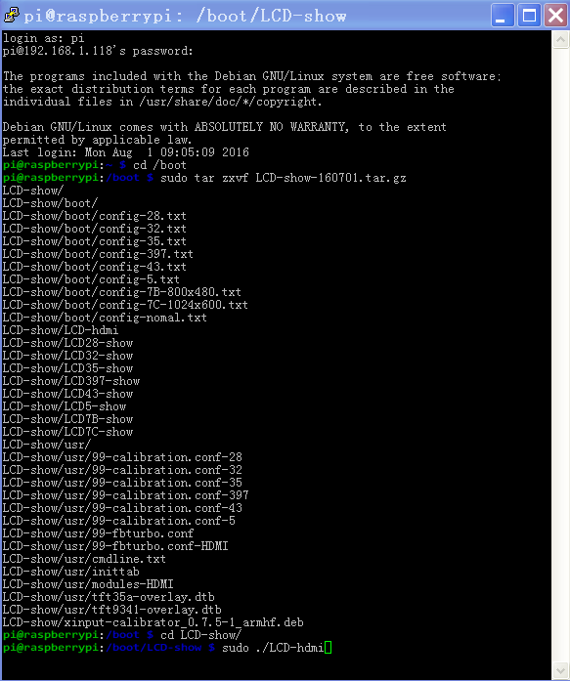

Just restart it and it is okay.

The above is the methods about how to add touch LCD driver for raspberry pie.

Thank you

KUMAN /FAE

